Last edited: Just now

Commonalities for S1000 & S2000 & S3000

* + Important Starting a new project
  + Important Exporting to revit/importing models from revit
  + Importing models
    - Designing the model
    - Sketch-up/Revit
      * J-school
      * What to model and what not to model
        + Question Model example in Revit
        + Model example in sketchup (<https://www.sketchup.com/plans-and-pricing#commercial>)
      * Importing a model from Revit/Sketchup/Customer Model
    - Multiple facilities
      * Origin points
  + Important Placing Grounding Electrode Arrays
    - Parts selection
    - Electrode array tool
  + Important Reports/BOM/pricing

S3000

* + Placing POIs (Points of Interest)
    - Placing POIs on corners
    - Placing POIs on edges
    - Analyze form tool
    - Placing POIs near air terminals
  + Placing air terminals
    - Placing POIs near air terminals
    - Location of air terminals
    - Parts selection
  + Analyzing results/changing design
    - What to do if any of the required checkpoints are not met
    - Optimizing designs
  + Placing down conductors
    - Parts selection
    - Conductor array tool
  + FAQ
    - How do I know my results are good?
  + Windloading document that has IP
  + LPMWRWW

S2000

* + Importing models
    - Designing the model
    - Sketch-up/Revit
    - Importing a model
    - Multiple facilities
      * Origin points
    - What to model and what not to model
  + Placing POIs (Points of Interest)
    - Placing POIs on corners
    - Placing POIs on edges
    - Analyze form tool
  + Placing air terminals
  + Terminal array tool
  + Location of air terminals
  + Parts selection
  + Analyzing results/changing design
  + What to do if any of the required checkpoints are not met
  + Placing down conductors
  + Parts selection
  + Conductor array tool
  + Placing Grounding Electrode Arrays
  + Parts selection
  + Electrode array tool

From <<https://teams.microsoft.com/_#/com.microsoft.teamspace.tab.wiki/19:meeting_MmIzZjY2MGEtN2UyNC00ZWM5LWI1NGEtYTA5ZGNjZGE0Y2Zi@thread.v2?threadId=19:meeting_MmIzZjY2MGEtN2UyNC00ZWM5LWI1NGEtYTA5ZGNjZGE0Y2Zi@thread.v2&ctx=chat>>

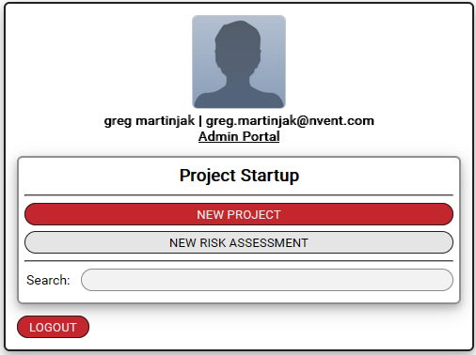

* What to do if your projects don’t show up when you log in
  + Log out – log back in